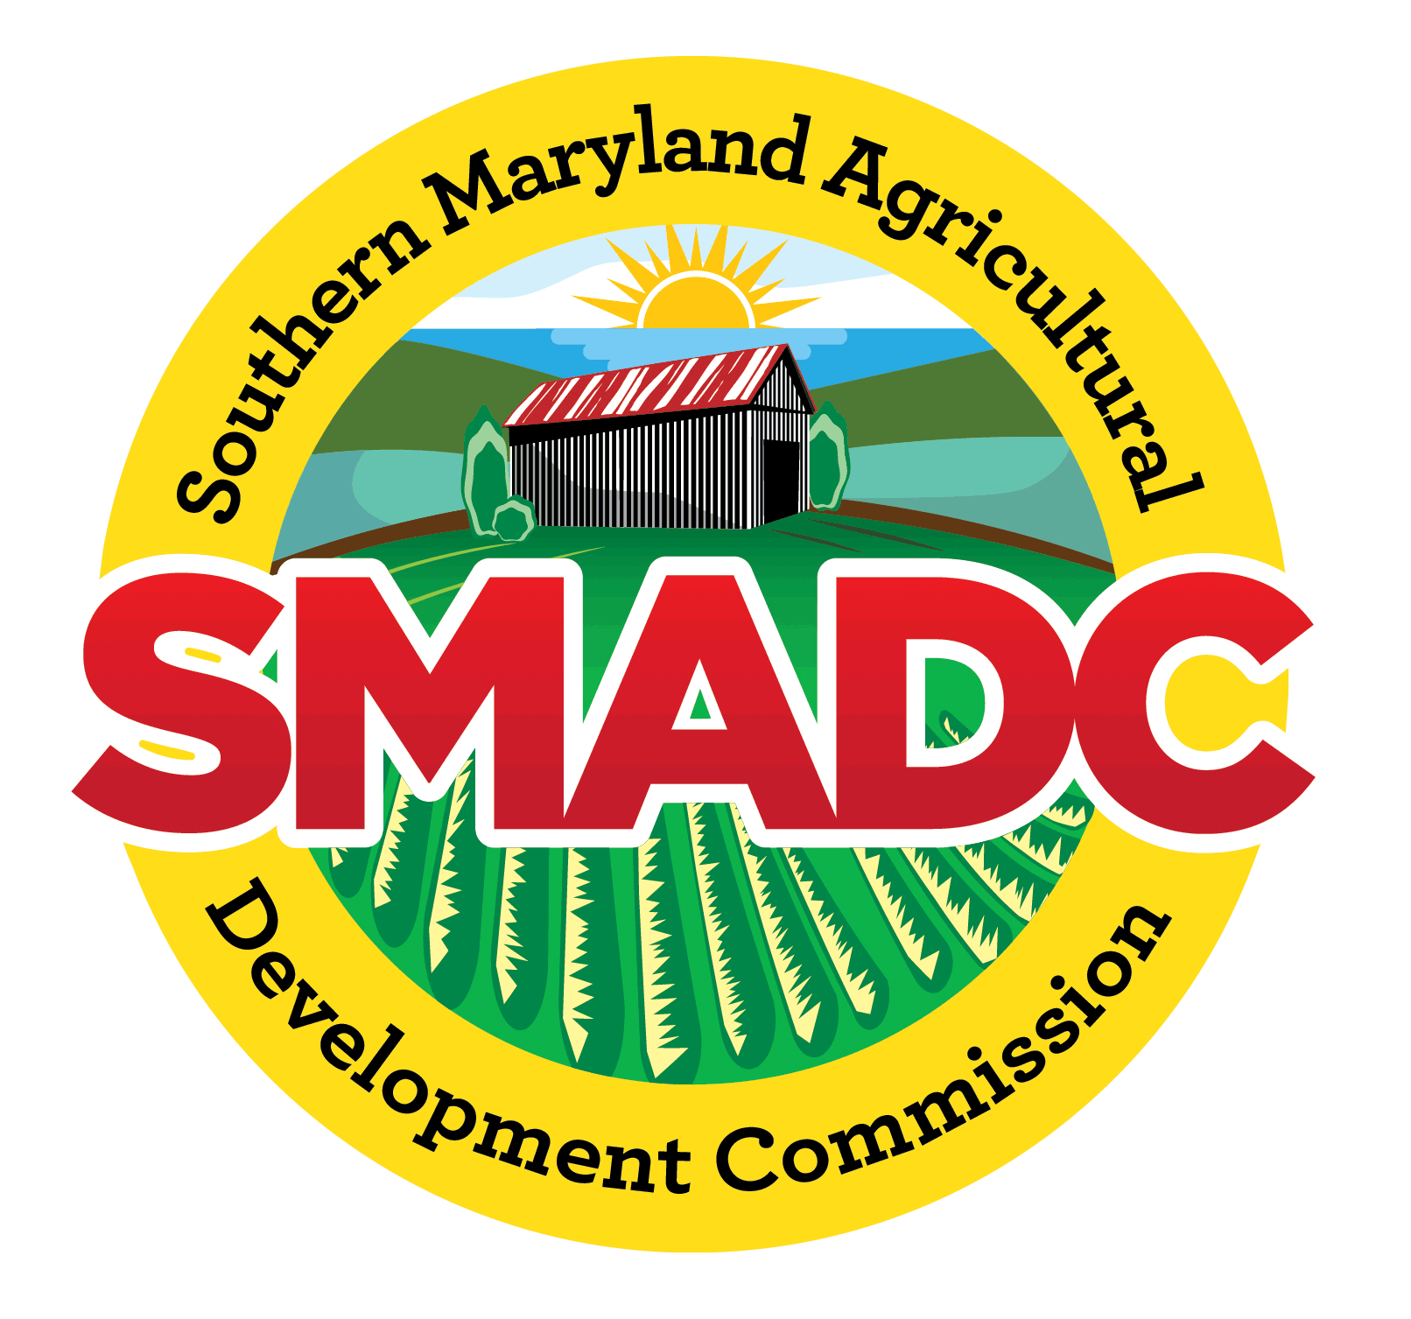

SMADC Southern Maryland Farmer Mini-Grant Program (Round 11)
Criteria and Guidelines
Grant Opens April 8th and closes May 8th, 2024
Grant Recipients notified in early June 2024

Stated Purpose: The Southern Maryland Agricultural Development Commission (SMADC) is offering another round of farmer mini grants. The Farmer Mini-Grant program was established by SMADC in 2016 based on feedback heard from the farming community about their needs. SMADC’s mission is to support farms and the future of agriculture in Southern Maryland, and we are committed to expanding and promoting a viable market-driven, sustainable, and profitable agricultural farming community.

This program is designed to assist both new and beginning farmers with small start-up projects and to assist experienced farmers who are looking to diversify or expand a current agriculture project.

The projects should be simple in scope and must be successfully completed within one year. SMADC awards will be up to $3,000 per applicant and are a one-to-one dollar match by the farmer.

Both Urban and Rural farms are encouraged to apply.

Funding: For this 11th round of grants in Spring 2024 $60,000 of funding is available. The number of applicants may exceed the amount of funding available and therefore applications will be ranked. See ‘Eligibility and Criteria’ at the end of this document.

Examples of Projects that would be considered:
- Services or equipment that help transition a farm’s sales strategy such as online sales, home delivery, on-farm sales, etc.; or for other projects that allow farm business to maintain and/or expand sales.
- Purchase of foundation livestock.
- Purchase of plant stock.
- Marketing and promotion of current farm operation.
- New fencing for enhancement, expansion, or protection.
- Hoop house.
- Materials needed for value-added production.
- Materials needed for on-farm upgrades to enhance food safety.
- Irrigation installation or upgrades in regard to GAP certification standards, Food Safety Modernization Act Standards (FSMA), chlorination systems, water testing expenses, drip irrigation, greenhouse irrigation, dedicated agricultural water supply, and overhead irrigation, as pertains to current existing wells or water sources.
- Washing/packing stations.
- Freezer/Refrigeration.

Agricultural Mini-Grants may not be used for:
- Maintenance and repairs of farm equipment.
- Administrative expenses or personnel.
- In-kind labor and matching funds from other state or federal grants.
- Improvements to current infrastructure, or repairs to existing structures, unless it can be demonstrated that the improvements will expand the overall agricultural economic impact of a current farm project.
- Project funding prior to grant submittal and approval. Funds spent before project grant submittal and approval cannot be reimbursed by the grant. Funding only applies to project costs after application approval.

Eligibility:
- Does not include non-profits or community organizations.
- Applicants must be living in the State of Maryland and actively farming in Anne Arundel, Calvert, Charles, Prince George’s, or St. Mary’s counties.
- Youth (16 years and older) who are in or have been in FFA, 4-H, agricultural related programs, or classes, or have a farming background are encouraged to apply.
- The applicant must match funds awarded dollar to dollar. For example, if the applicant is awarded $500, they must put $500 toward the project budget. Matching must be in dollars, not in-kind or labor.
- No more than one application is awarded per individual or business entity during a 12-month period.
- Only completed applications with all applicable supporting documentation attached will be considered.

Criteria:
- The project and application are consistent with definition of the Agricultural Mini-Grant stated purpose.
- Demonstrated ability of applicant to initiate, administer and complete project within proposed timeframe and budget.
- Matching dollar funds are required for this grant.
- One letter of reference from either your county’s Soil Conservation District, Farm Bureau, University of Maryland Extension, or Economic Development Office.
- If the applicant is not 18 years old, a letter from their parents or guardian allowing them to apply for the Agricultural Mini-Grant is required.
- Only complete applications meeting all eligibility with all the required documents submitted will be considered.

Documents Required:
Farmers must provide the following documents to be uploaded with their application via the application portal:
  - Proof that the enterprise is a real and existing farm business; this documentation can be in the form of a Schedule F, K1 Form, a 1120S, LLC or S-Corp documents, or other official document proving the farm business is in existence.
  - Proof of farm property (urban or rural) ownership where the project is taking place or a farm lease agreement for the property where the project is taking place.
  - Proof that the property is zoned for agricultural purposes, for urban agricultural purposes, or otherwise appropriately for the project proposed.
  - If the proposed project requires the addition of infrastructure to the farm, and permits are required by the county or jurisdiction for that infrastructure, the approved permits must be provided.
  - A copy of the farm’s current Nutrient Management Plan, if applicable.
Maryland law requires all farmers grossing $2,500 a year of more or livestock producers with 8,000 pounds or more of live animal weight to follow nutrient management plans when fertilizing crops and managing animal manure. Nutrient management plans specify how much fertilizer, manure or other nutrient sources may be safely applied to crops to achieve yields and prevent excess nutrients from impacting waterways.
  - Applicants are required to upload a W9. Your name/or business name on the application and the W9 must match to receive the grant funds. Documents presented with the application will remain confidential to SMADC/TCCSMD Admin.

Application Procedure:
  - Applications must be submitted online.
  - Applications must be received by May 8th, 2024.
  - After the applicant applies, an email will be sent to confirm receipt of the application.
  - Submissions will be reviewed and evaluated by an independent Mini-Grant Review Committee.
  - Applicants will be notified if they are awarded the grant, are declined the grant, or if the grant review committee suggests changes to the application by early June 2024.
  - Projects must be completed per the agreement, or the farmer will be required to return the funds.

Terms:
1. Signed agreement between applicant and SMADC.
2. The grantee has one year from receiving the funds to complete the approved project, after which a short Grant Report is required to be submitted to SMADC with the following information included:
• A brief narrative about the project purpose, the impact of the project, and one or two photos
• Statement of expenditures of both the awarded and the matching funds (attachment).
• Copies of invoices and receipts (attachment).
The grant report is due by July 1st, 2025.
3. Grant Report extensions may be considered on a case-by-case basis for delayed project completion due to supply chain issues and other unforeseen circumstances. An interim report of the project status will be required.
4. SMADC will list award recipients on SMADC’s website.
5. Awardees may also be featured on SMADC’s other materials, and SMADC will assist in marketing and promoting of the project.
6. Grantees may be asked to present their completed project to the SMADC Commission at one of the Commission’s virtual monthly meetings.

Contact: info@smadc.com l www.smadc.com l #240-528-8850

* By submitting photograph(s), you warrant that you are the owner and/or holds the copyright to the photograph(s) submitted and that you are not violating any laws or regulations or infringing on any rights by submitting the photograph(s), including, but not limited to, violating any trademark/copyright laws or any privacy or publicity rights. Furthermore, you understand and acknowledge that SMADC intends to use and publish submitted photograph(s) on SMADC's various digital and print platforms. Therefore, by submitting photograph(s) you understand and agree to grant SMADC a non-exclusive, royalty-free, worldwide right to copy, crop, edit, publish, display, distribute, sublicense, or otherwise use the photograph(s). In addition, you understand and agree that, by submitting photograph(s), you do not have any right of approval as to how SMADC uses the photograph(s) and that you will not be compensated in any way by SMADC for the use of the photograph(s). You agree that SMADC is under no obligation to use any of the photograph(s) submitted and whether submitted photograph(s) are used is at the sole discretion of SMADC.
