SAMPLE NARRATIVE TEMPLATE

Important! This ‘sample narrative’ is supplied as a guide for your own unique plan and is not intended to be used ‘as is’. Please insert your farm details in the ‘blue’ areas and any additional critical information about your individual operation which may include, but is not limited to the following:
- The breeds of animals you will be taking to slaughter
- Physical address of farm, and contact information
- The name and address of your chosen USDA slaughter/processing facility
- Description of meat cuts that will be sold
- A copy of the slaughter facility USDA inspection *label(s) (indicating meat cut, weight, and safe handling instructions, and producer farm name and address).
- Description of how your meat products will be transported back to your farm
- Description of where and how your meats will be stored on the farm

*If using more than one slaughter/processor, please include the inspection label for each USDA facility processing your meats.

Your farm name:
Your farm address: (street, city, state, zip)
Your farm contact information: (telephone, email)

Date:

List all meats intended for ‘on-farm’ sale: beef, pork, lamb, goat, poultry, etc.)

(Your farm name) will take live (list all breeds you will take to slaughter) to the (name(s) of your slaughter/processor) facility to be processed. The (name(s) of slaughter/processor facility/facilities) is located at (address of slaughter/processor facility/facilities), and is a USDA processing facility with the capability to kill, hang, cut, wrap, label and freeze the meat. The frozen meat will have a label indicating the cut of meat, weight, farm name, complete farm address, and farm phone number. The meat will be priced per package at the farm. A copy of the (name(s) of slaughter/processor facility/facilities) label(s) is shown in Figure 1. below:

Farm Name Here

(meat and cut description here e.g.,
BEEF SIRLOIN TIP STEAK)
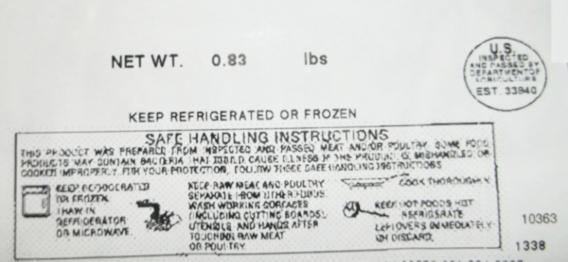
PKG FOR: (your farm name and address & telephone number here)

Figure 1: (name(s) of slaughter/processor facility/facilities) Label(s)

(Your farm name) will then haul the frozen meat products using (describe your transportation method i.e., freezer trailer, include MD tag number if applicable) back to the farm located in (name of county) at (your farm address).

The frozen meat will be stored in a (make, model, and serial number of your dedicated meat freezer) freezer, which is located in (describe where your freezer is located on your farm premises). The freezer will contain only the meat processed at (name of slaughter/processor facility) and will be kept locked. A thermometer will be placed in the freezer to monitor the temperature (describe type of thermometer – data logger or conventional. If using a conventional thermometer describe how often you will check the freezer temperature and how you intend to keep a record of the temperature). The freezer will be maintained at or below 0 degrees Fahrenheit at all times.

